SQL Practice Questions

QUE 1

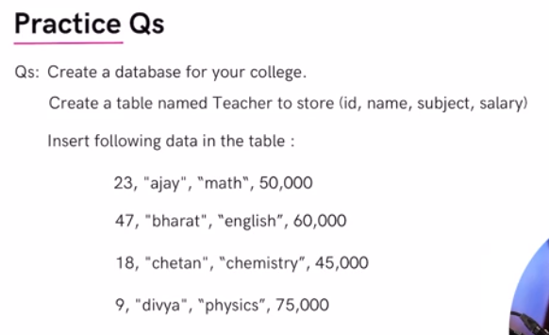



SHOW DATABASES;

CREATE DATABASE college;

USE college;

CREATE TABLE IF NOT EXISTS teacher(
id INT PRIMARY KEY,
name VARCHAR(30),
subject VARCHAR(20),
salaray DOUBLE
);

SELECT * FROM teacher;

ALTER TABLE teacher
CHANGE COLUMN salaray salary DOUBLE;

INSERT INTO teacher (id, name, subject, salary)
VALUES (23, "ajay", "math", 50000),
(47, "bharat", "english", 60000),
(18, "chetan", "chemistry", 45000),
(9, "divya", "physics", 75000);

SELECT * FROM teacher
WHERE salary > 55000;

-- Rename Column--
ALTER TABLE teacher
CHANGE COLUMN salary ctc INT;

SELECT * FROM teacher;

-- Update Column--
UPDATE teacher
SET ctc = ctc*1.25;

-- Add Column --
ALTER TABLE teacher
ADD city VARCHAR(20) DEFAULT "Gurgaon";

-- Delete Column--
ALTER TABLE teacher
DROP COLUMN city;

QUE 2

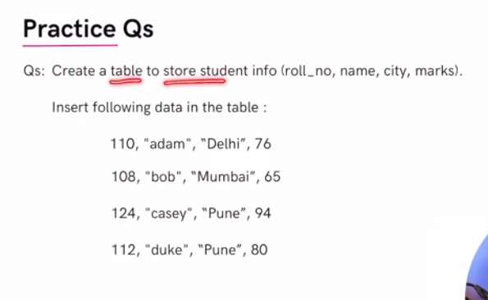
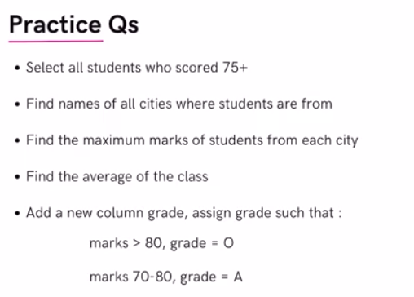
USE college;

CREATE TABLE IF NOT EXISTS student(
roll_no INT PRIMARY KEY,
name VARCHAR(20),
city VARCHAR(30),
marks DOUBLE DEFAULT 0
);

INSERT INTO student (roll_no, name, city, marks)
VALUES
(110, "adam", "Delhi", 76),
(108, "bob", "Mumbai", 65),
(124, "casey", "Pune", 94),
(112, "duke", "Pune", 80);

SELECT * FROM student;

SELECT * FROM student
WHERE marks > 75;

SELECT city FROM student
GROUP BY city
ORDER BY city;

SELECT city, max(marks) FROM student
GROUP BY city
ORDER BY Max(marks) DESC;

SELECT AVG(marks) FROM student;

ALTER TABLE student
ADD COLUMN grade CHAR(1);

UPDATE student
SET grade = "B" WHERE marks <70;
UPDATE student
SET grade = 'A' WHERE marks BETWEEN 70 AND 80;
UPDATE student
SET grade = 'O' WHERE marks>=80;

SELECT * FROM student;

